
KEMENTERIAN PENDIDIKAN DAN KEBUDAYAAN
Direktorat JENDERAL KEBUDAYAAN
Jalan Jenderal Sudirman, Senayan, Jakarta 10270
Telepon (021) 5725542; Faksimile (021) 5725542
Laman www.kebudayaan.kemdikbud.go.id
Pos-el ditjenkebudayaan@kemdikbud.go.id

Keterangan:
- Tuliskan keterangan foto (caption) terkait ketiga foto berikut. Keterangan foto harus kreatif dan informatif dengan sasaran kaum millennial:
- Sertakan tagar #BudayaSaya dan #WBTB #SahabatPandu2021.

Selamat Mengerjakan!

GAMBAR 1: Warisan Budaya TakBenda

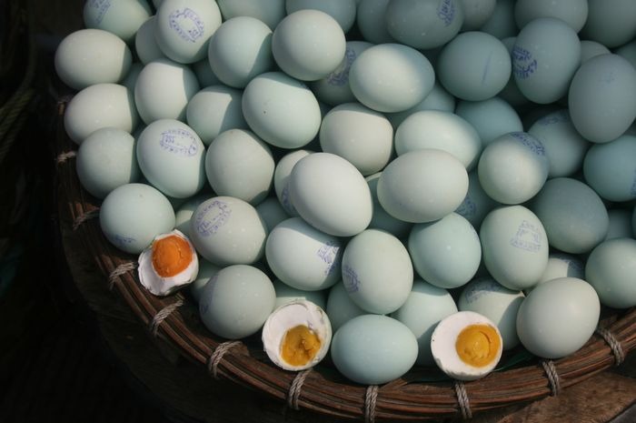

Keterangan gambar: Telor Asin Brebes

Keterangan Foto/Caption (Instagram): ……………………………………………………………………………………………………………………………………………………………..………………………………………………………………………………………………………………………………………………………………………………………………………………………………………………………………………………………………………………………………………………………………………………………………………………………………………………………………………………………………………………………………………………………………………………………………………………………

Keterangan Foto/Caption (Twitter): ………………………………………………………………………………………………………………………………………………………………………………………………………………………………………………………………………………………………………………………………………………………………………………………………………………………………………………………………………………………………………………………………………………………………………………………………………………………

GAMBAR 2: Benda Cagar Budaya
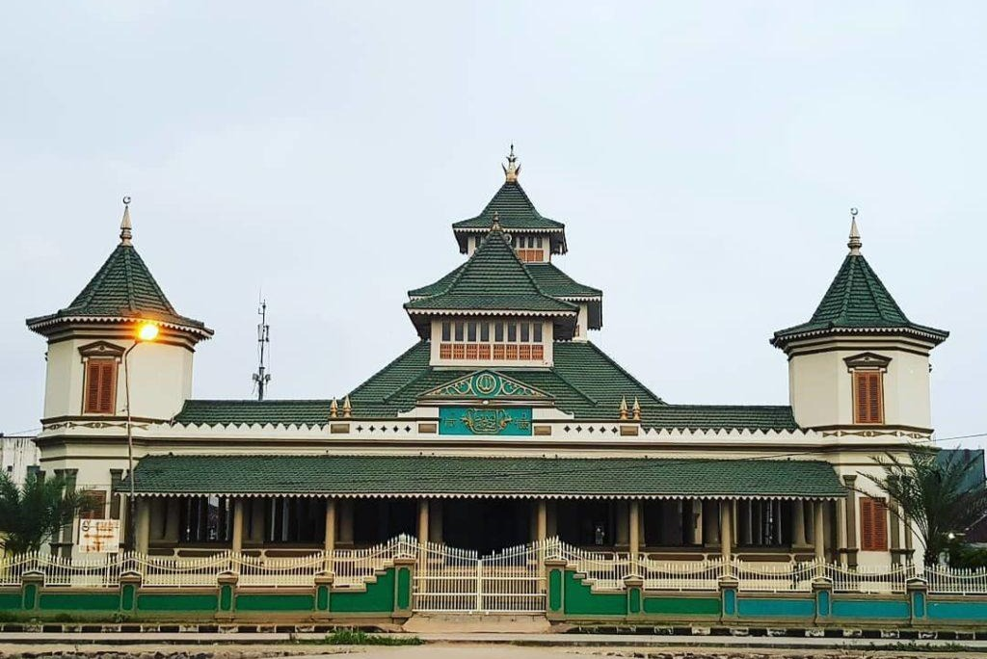

Keterangan gambar: Masjid Agung Manonjaya

Keterangan Foto/Caption (Instagram): ……………………………………………………………………………………………………………………………………………………………..………………………………………………………………………………………………………………………………………………………………………………………………………………………………………………………………………………………………………………………………………………………………………………………………………………………………………………………………………………………………………………………………………………………………………………………………………………………

Keterangan Foto/Caption (Twitter): ………………………………………………………………………………………………………………………………………………………………………………………………………………………………………………………………………………………………………………………………………………………………………………………………………………………………………………………………………………………………………………………………………………………………………………………………………………………

GAMBAR 3: Tokoh

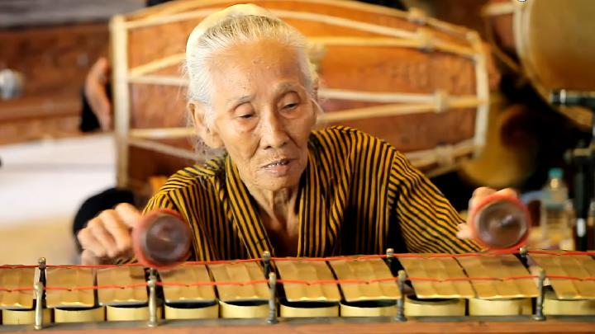

Keterangan gambar: Sumiyati (Mbah Pringgp), Maestro Seni Tradisi

Keterangan Foto/Caption (Instagram): ……………………………………………………………………………………………………………………………………………………………..………………………………………………………………………………………………………………………………………………………………………………………………………………………………………………………………………………………………………………………………………………………………………………………………………………………………………………………………………………………………………………………………………………………………………………………………………………………

Keterangan Foto/Caption (Twitter): ………………………………………………………………………………………………………………………………………………………………………………………………………………………………………………………………………………………………………………………………………………………………………………………………………………………………………………………………………………………………………………………………………………………………………………………………………………………

